What international means for our students
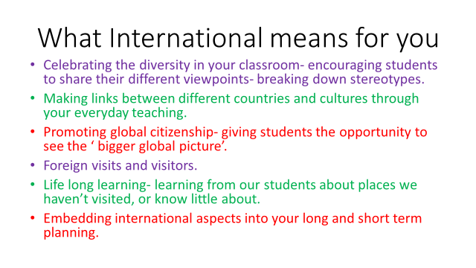

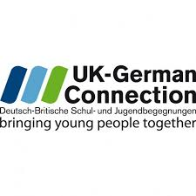
Our Year 2 Students were lucky enough this year to have a visit from Alex the Bear. Alex had come all the way from Germany to stay with us for 3 week and to learn about British culture. In the meantime, Ben the Bear went to IPS Stohlberg.

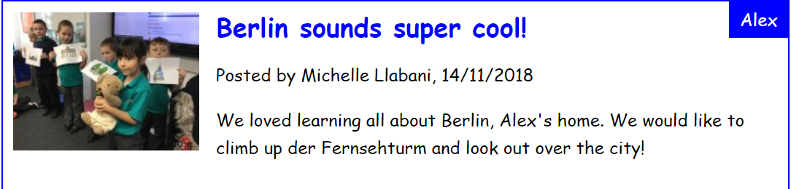
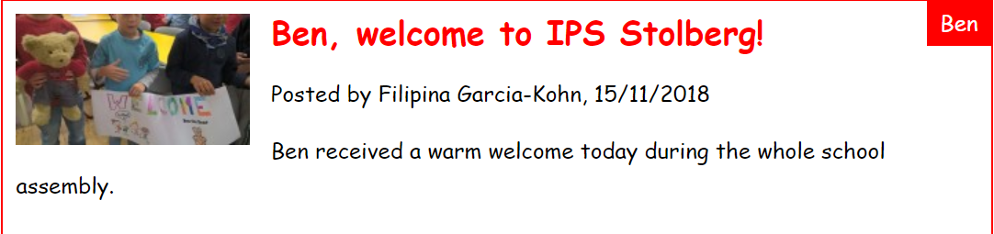

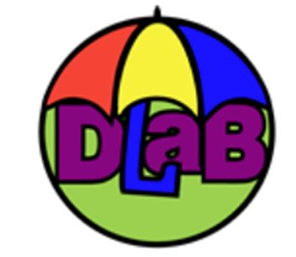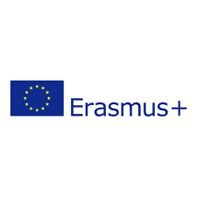

NIA are working with the University of Northampton on a European wide Erasmus project, developing digital learning across boundaries.
Students at NIA have worked with teachers, student teachers and lecturers from across Norway, Belgium and Denmark to produce a project on sustainable living in the event of a rise in sea levels.

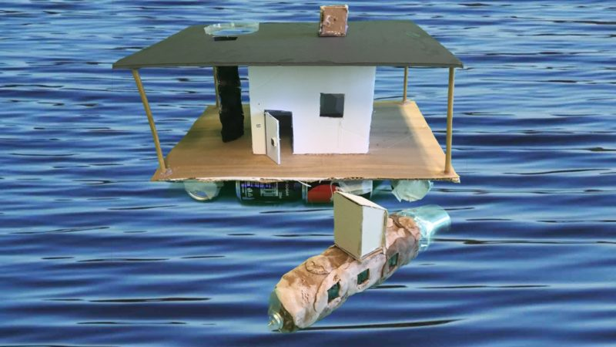

There is a fabulous book that has been created with our student’s work here:
https://read.bookcreator.com/I5AsnkkvGrR4IYhydUdNxh6Wj5J2/3bEKBboWROykAqTuqqKwTg?fbclid=IwAR1wK2ewe1x0yl6YJ0ESr6f6ipHffKJmKjSppzt_WMihrQi05T86Bk4H4x4

European Day of Languages
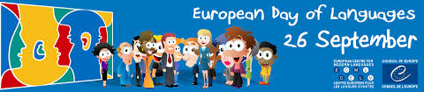

An annual event tin our school calendar. Students spend the day exploring cultures and traditions different from their own. Students love coming to school in clothing which reflects their cultural heritage.

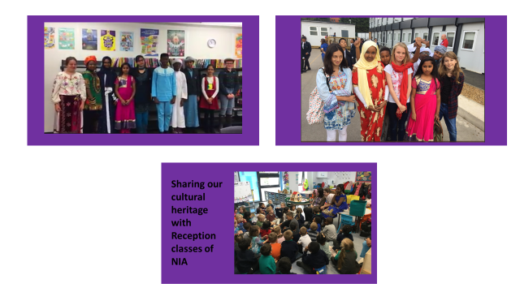

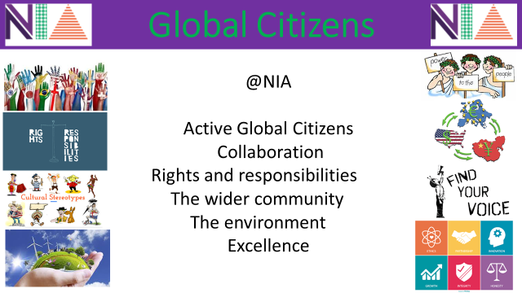
At NIA we are proud to be global citizens. Students are encouraged to show an understanding of the role each of our global pillars play in making them excellent citizens of the world.
As part of our reward system, students collect signatures from staff when they can show they have used one of our global pillars- this leads to reward point and school trips for those who complete the most!

At NIA we encourage independent thinkers and independent work. We are always thrilled when students choose to do that little bit extra.
Each term students are given the option to do an extra-curricular independent project relating to our global pillars. Here are the ones we have had so far.
